Ridge Lines
News from Kestrel Ridge Wind Farm – Autumn 2026
Tom Berger · 25 September 2026
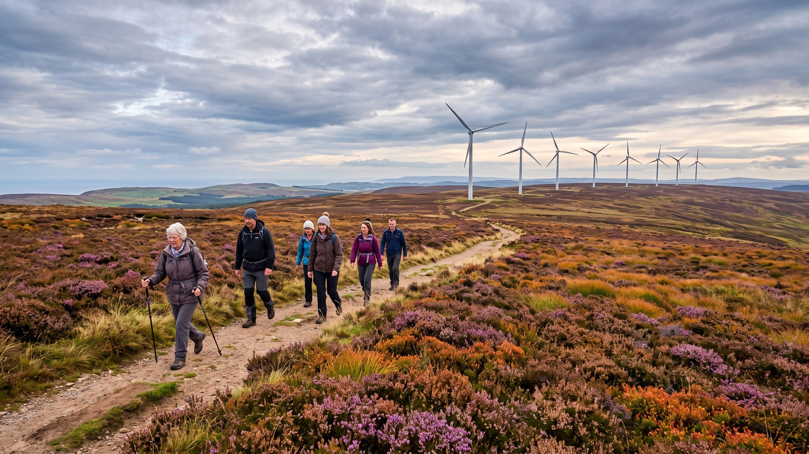

Turbine T-07 back in service
In January turbine T-07 had a gearbox bearing failure. The gearbox was exchanged under warranty and the turbine was back after 23 days. You may have seen the large crane on the ridge – thank you for your patience with the convoy on the B-road.

Community fund: spring round record
The panel awarded 17 grants worth GBP 226,400 in April. Glenhope Primary will get solar panels on its roof. The autumn round is open until 31 October.

School visits
More than 500 pupils have visited the wind farm this year. Glenhope Primary visits on 6 October.

Performance
In 2025 Kestrel Ridge generated 206.6 GWh with an availability of 97.4 % – enough for about 57,000 homes.
[David – can you confirm the 2026 year-to-date figure before we print? Tom]

